**PROJECT 3:**

PROJECT 3 NETBEANS:

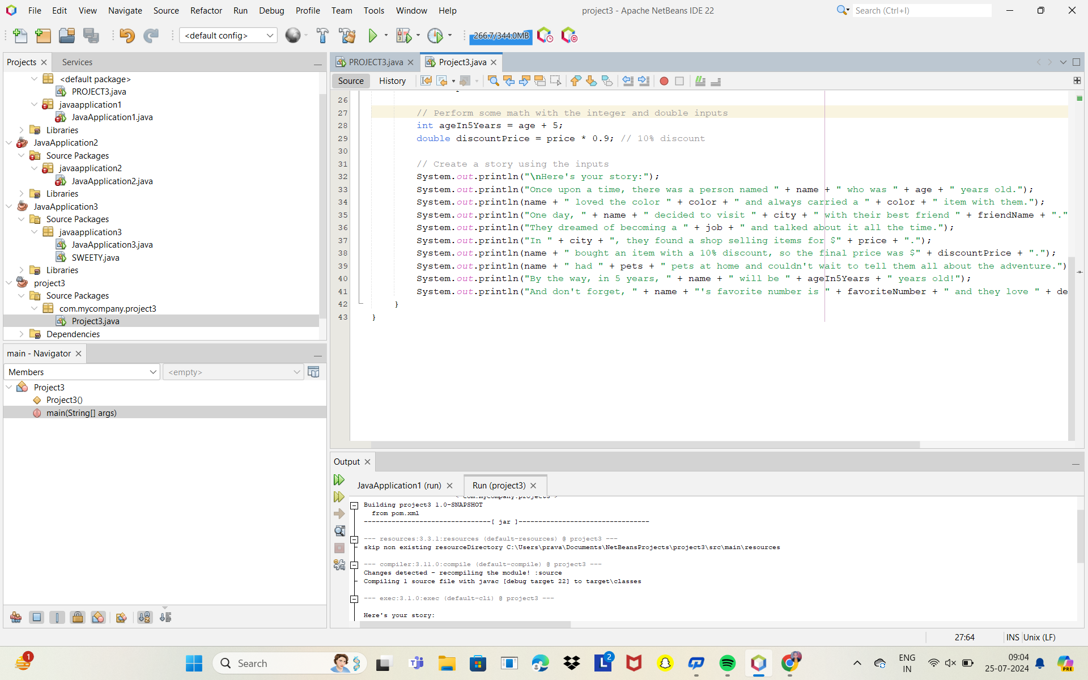

PROJECT 3 ECLIPSE:

